Y1 Newsletter

A very happy new year!
We hope that you have all had a fabulous Christmas break and look forward to a busy term ahead.
Topics
For the first half of this term our topic is ‘Toys’. We had a short introduction to this at the end of last term, reading the story of ‘The Nutcracker’. This half term we will use more toy stories, look at toys past and present and in science think about materials and their properties.

After half term our topic will be ‘Out of Eggs’.

More information to follow nearer the time!
The Year 1 team 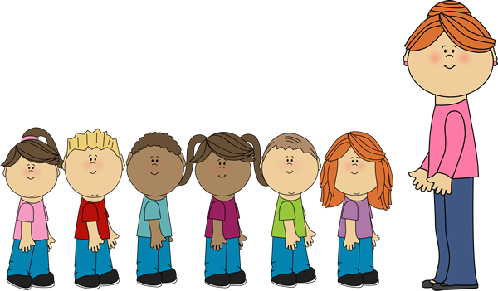
Mrs Brazier (Mon – Thurs); Mrs Rogers (Fri)
Mrs Wilson, Mrs Rogers, Miss Foulkes,
Mrs Fearn

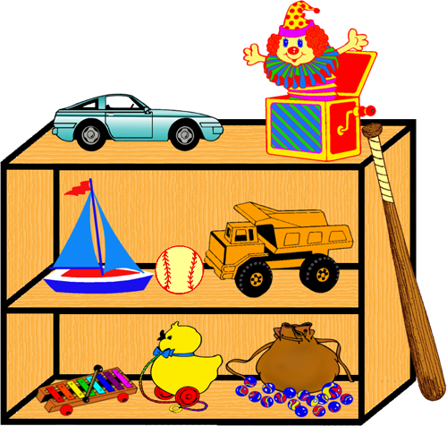
Homework
- 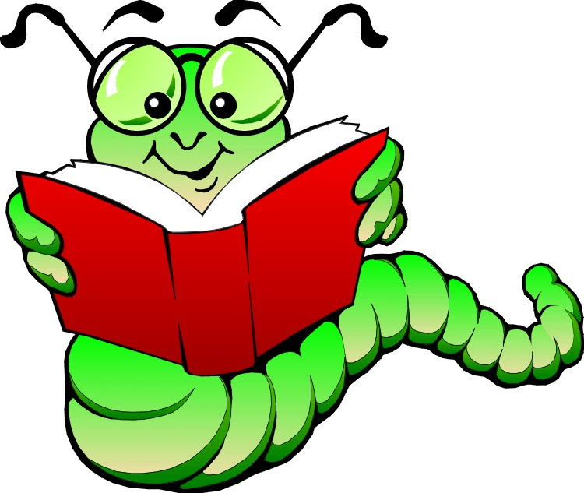Daily reading – Each child will bring home a guided reading book, an independent reading book and in time a library book of their choice. Please, as far as is possible, hear your child read daily, record the text your child has read in their home/school diary and sign each day. Please also sign when your child has completed the independent book so that it can be changed.
- Weekly spellings – These will be given out each Tuesday (stuck into their homework book on a ‘look, say, cover, write, check’ chart for practising) and tested on the following Monday.
- Maths / Literacy – A maths or literacy activity will be set each Tuesday in their homework books. These activities need to be completed and the homework book returned the following Monday. Any written work should be completed using pencil please – not biros or pens.

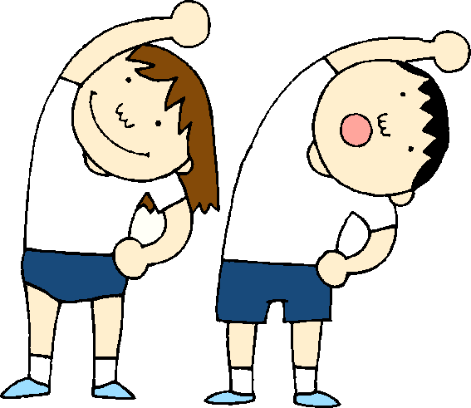Please make sure that your child has their named PE kit (plain white t-shirt and navy shorts), painting apron and wellies in school every day.
P.E will mainly be on Monday and Tuesday this term.

If you have any concerns, worries or just need a quick word you can usually catch Mrs Brazier at the end of the school day.
Thank you for your help and support.

